Institute of Technology of Cambodia

Département de Génie Informatique et Communication

Department of Information and Communication Engineering

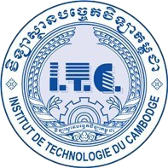

|  |  |
| --- | --- |
| Professeur      Subject      Assigment | : HOK TIN  : Internet Programming  : TP11- Web app,CRUD API |
| STUDENT | : THUE NARATT |
| Group | : I4GIC© |

ID : E20191186

YEAR : 2023-2024

Contents

TP11.1: CRUD Apis 3

TP11.2: TopOne app 10

URL: https://github.com/thuenaratt/TP11

# TP11.1: CRUD Apis

Create APIs to manage products by categorizing/sub-categorizing.

* CRUD APIs for category

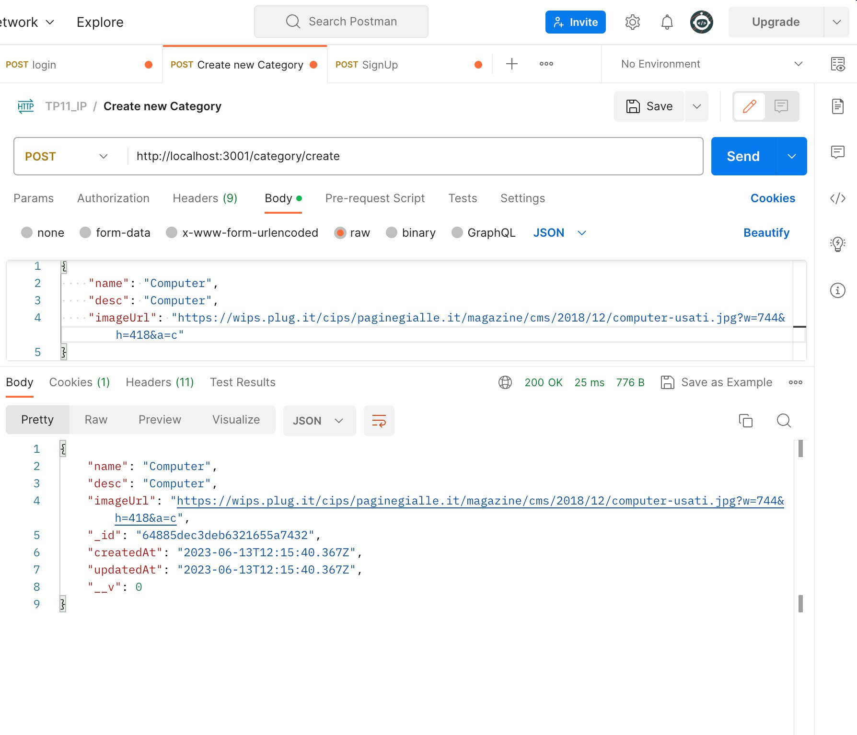

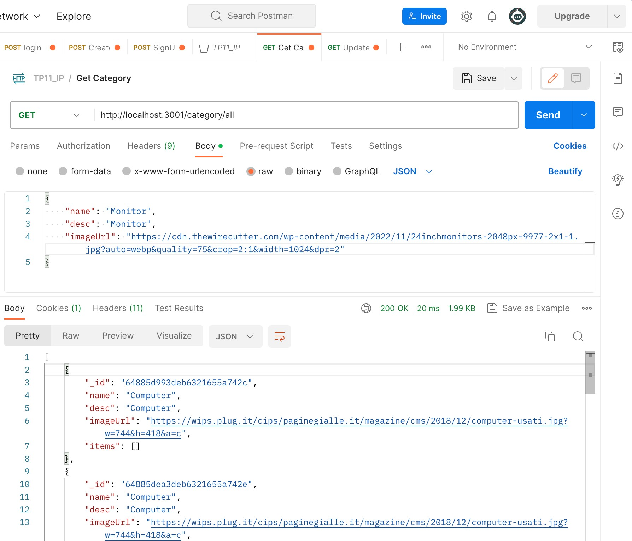

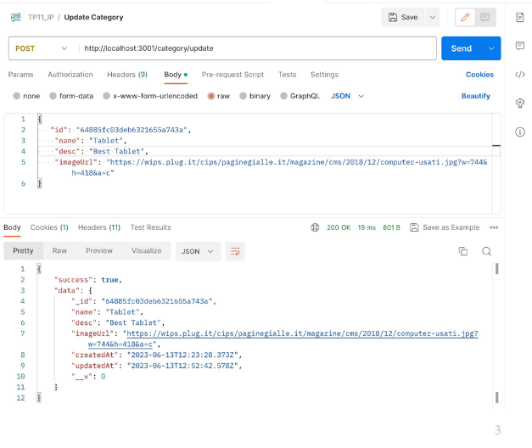

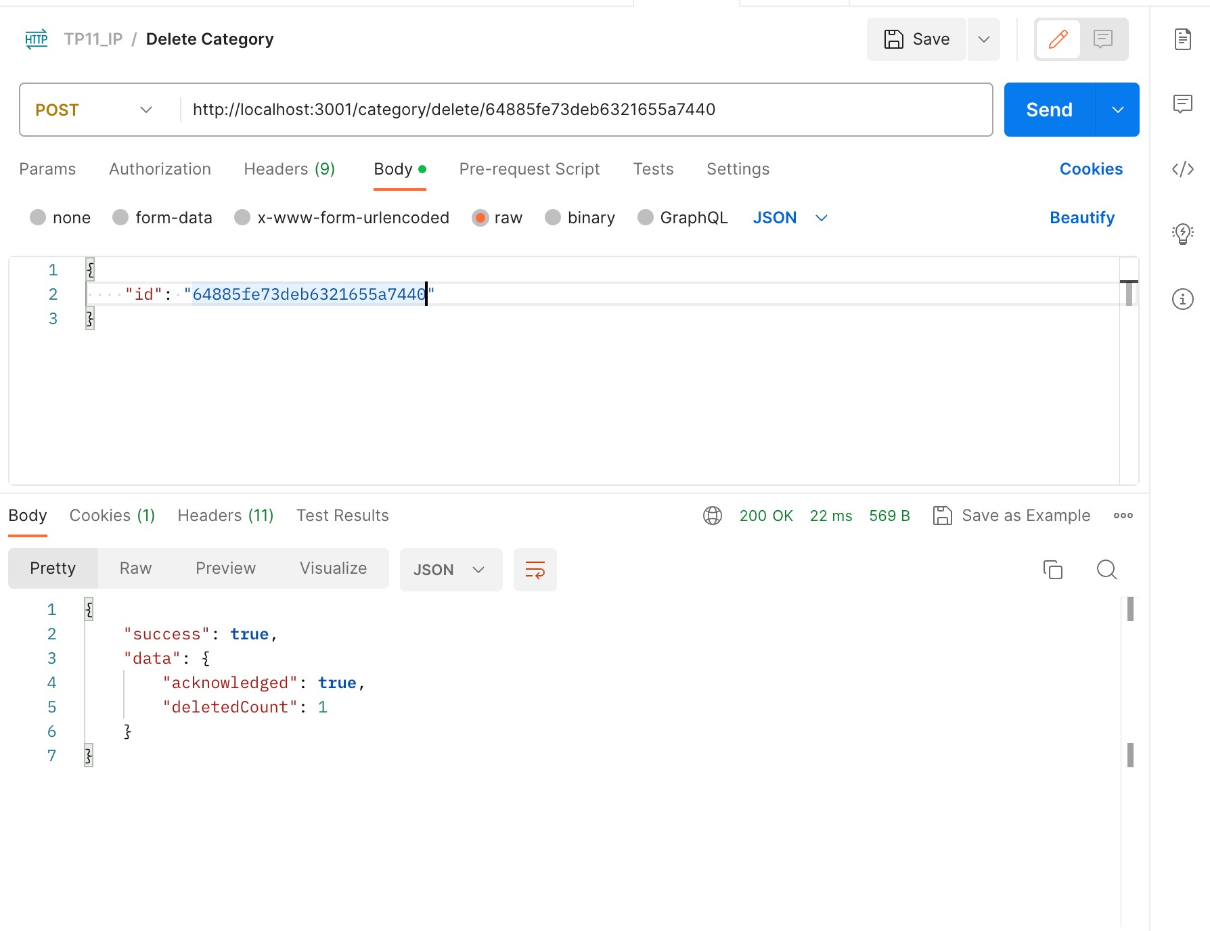

* CRUD APIs for sub-category

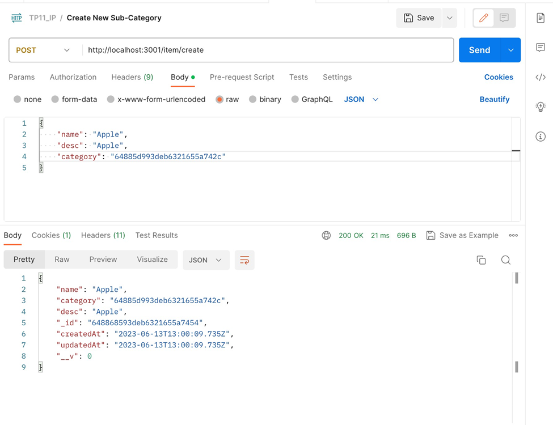

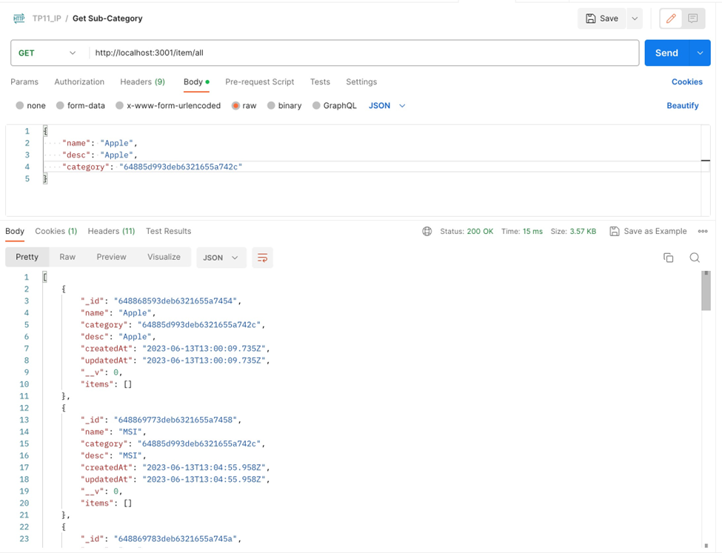

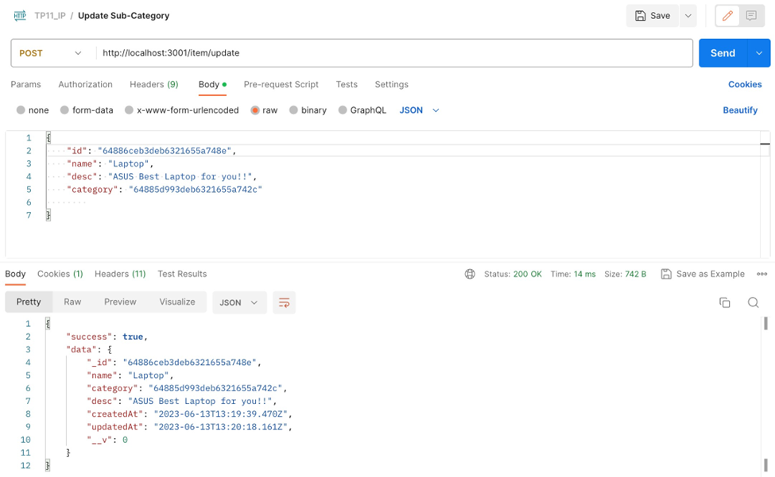

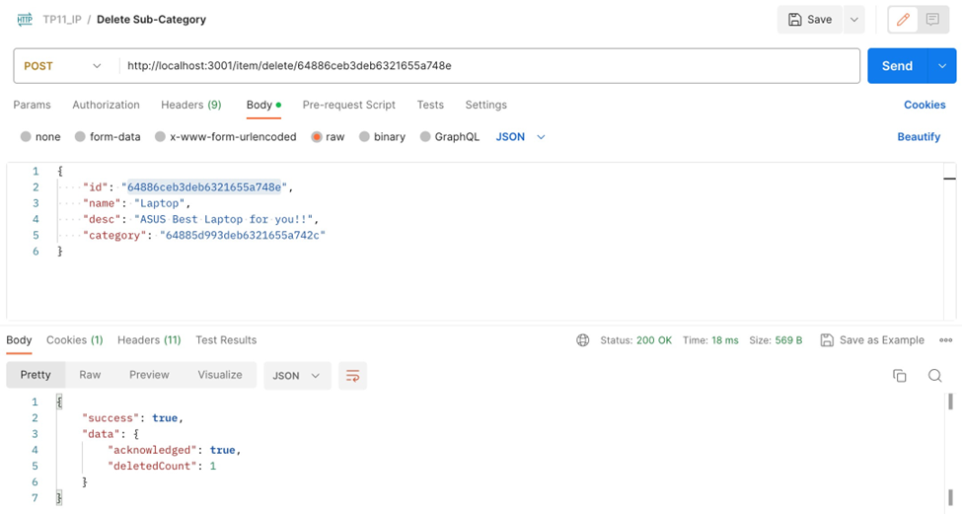

* CRUD APIs for product

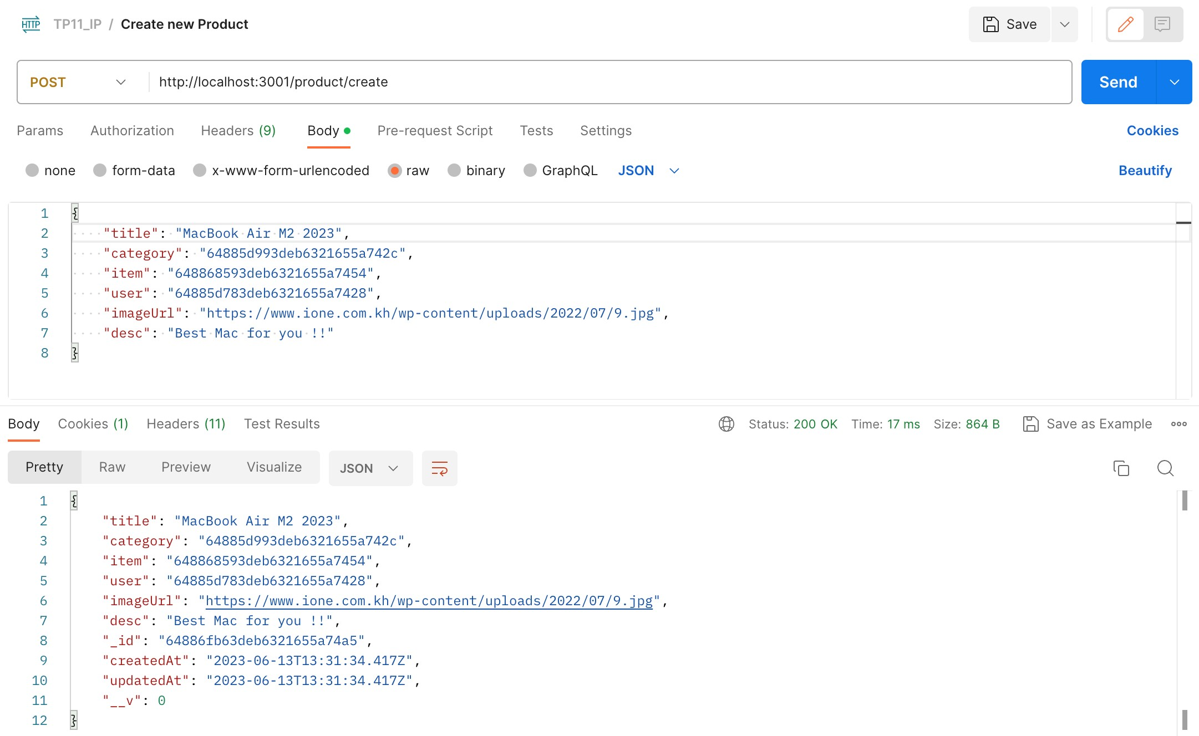

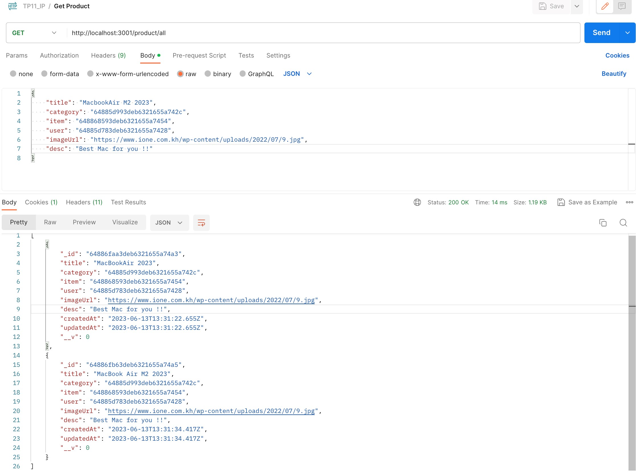

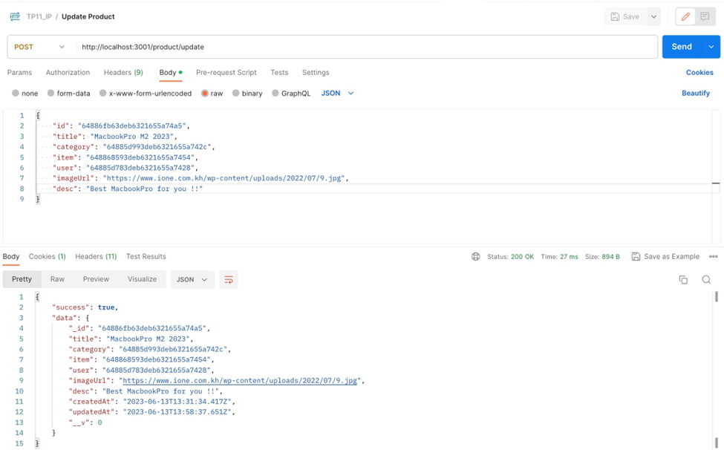

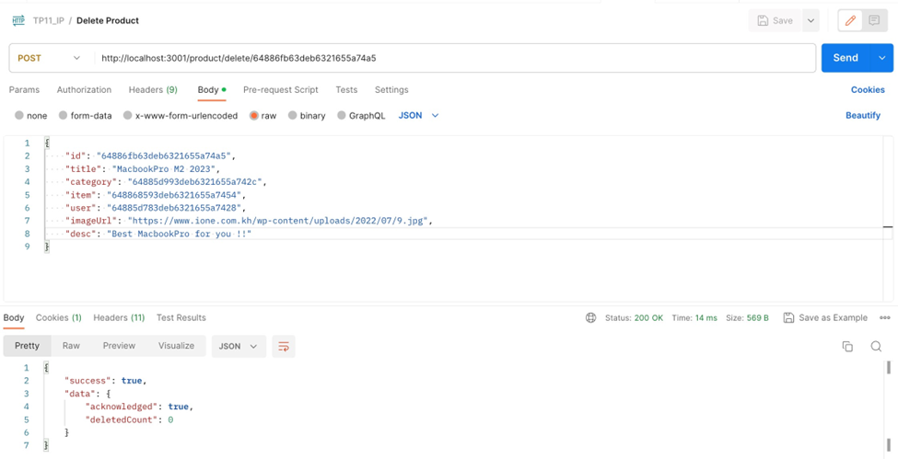

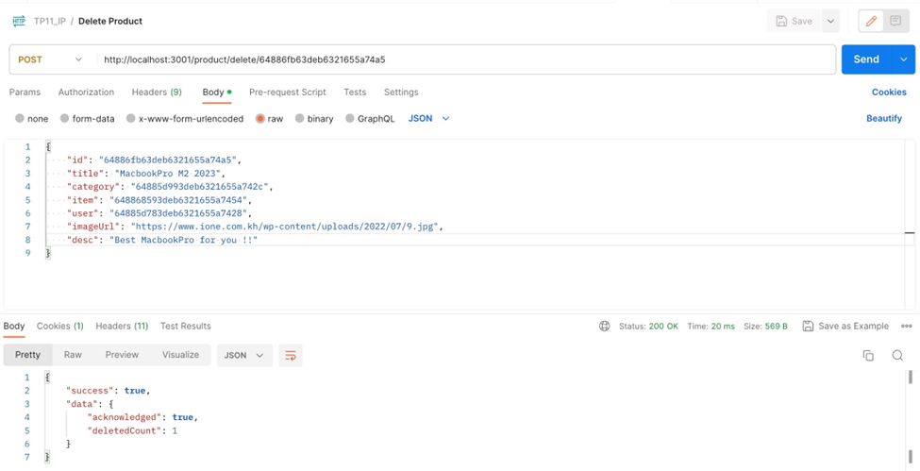

# TP11.2: TopOne app

Design a basic website template to compare product price tags from different sources.

